

2023 Annual Report of Demand Response

in the ERCOT Region

December 2023

This report is a summary of the various Demand response products that are available in the ERCOT Region.[1] Some of these, such as participation from Load Resources and Emergency Response Service, are directly administered by ERCOT, and therefore are easily quantifiable. The Transmission/Distribution Service Provider (TDSP) Load Management Programs are administered by the various TDSPs in the competitive choice areas of the ERCOT Region but are reported to ERCOT and are available to be deployed through an ERCOT-issued instruction to the TDSPs. Participation from the remaining Demand response products included in this report are derived from detailed analysis of meter data associated with the ESIIDs provided through the annual Price Responsive Demand Response Survey, or through analysis of the boundary meter data available from Non-Opt-In Entities (NOIEs). The Demand response products included in this report are:

* Load Resource Participation in ERCOT’s Ancillary Services and Real-Time energy market
  + Responsive Reserve Service (RRS)
  + Regulation Service
  + Non-Spinning Reserve (Non-Spin) and Security-Constrained Economic Dispatch (SCED)
  + ERCOT Contingency Reserve Service (ECRS)
  + Controllable Load Resources (CLRs)
  + Aggregate Distributed Energy Resource (ADER) Pilot Project
* Emergency Response Service (ERS)
* TDSP Load Management Programs
* 4-Coincident Peak (CP) Load Reduction
* Price-Responsive Demand Response

**Load Resource Participation in ERCOT Ancillary Services**

**Responsive Reserve Service (RRS)**

Most of the Demand response Resources, both by number of units and by capacity volume, that participate in the ERCOT Ancillary Service markets are Load Resources controlled by high-set Under-Frequency Relays (UFR). These Load Resources are commonly referred to as Non-Controllable Load Resources (NCLRs), and they participate in the RRS market.

During 2023, Market Participants stopped and de-registered a net of 85 more NCLRs than they registered. As of the end of November 2023, there were 490 registered NCLRs, with an aggregate capacity of 8,690.2 megawatts (MW) that were qualified to provide RRS. It is important to note that at any given time not all of these Load Resources are at their maximum Load value, nor are they all participating in the RRS market. Table 1 below shows the monthly statistics for the hourly offers and self-arranged capacity from all Load Resources that were participating in RRS from December 2022 through November 2023.

*Table1: RRS hourly offers including self-arranged amounts from NCLRs (MW) 12/22 through 11/23*

|  |  |  |  |
| --- | --- | --- | --- |
| Month | Minimum Hour | Maximum Hour | Average per Hour |
| December 22 | 980.6 | 2671.3 | 2060.8 |
| January 23 | 1962.9 | 2941.1 | 2388.8 |
| February 23 | 1601.9 | 3041.7 | 2393.1 |
| March 23 | 1974.8 | 2834.9 | 2231.9 |
| April 23 | 1668.7 | 2258.2 | 1911.5 |
| May 23 | 1715.9 | 2807.8 | 2207.8 |
| June 23 | 1451 | 3042.3 | 2477.5 |
| July 23 | 1492.4 | 3435.2 | 2706.3 |
| August 23 | 1434.5 | 3141.7 | 2351.7 |
| September 23 | 1257.6 | 2971.6 | 2377.2 |
| October 23 | 402.9 | 2772.5 | 2166.5 |
| November 23 | 1456.7 | 2067.8 | 1782.4 |

The expected amount of RRS that is required for any given hour is shown in the Ancillary Service Plan, and the required amount with any updates for the next day are communicated to each Load Serving Entity (LSE) at 0600 in the Day-Ahead Market (DAM). For 2023, the amounts varied from 2,300 MW for Hours Ending 1100 – 1400 during July and August to 3,335 MW for Off-Peak hours in March. There is a constraint that limits participation to 60% of the total required RRS capacity to be provided by NCLRs, subject to a second constraint that requires at least 1,390 MW of RRS capacity to come from Resources providing Primary Frequency Response (PFR). That constraint is based on the Interconnection Frequency Response Obligation (IFRO) that is established by NERC. The IFRO that will go into effect on January 1, 2024, will decrease that constraint to 1,185 MW. ERCOT’s Ancillary Service methodology is being revised to reflect that change for 2024.

Table 2 below shows the statistics for awards and self-arranged capacity for NCLRs participating in the RRS market during each month from December 2022 through November 2023.

*Table 2: RRS hourly awards including self-arranged amounts from NCLRs (MW) 12/22 through 11/23*

|  |  |  |  |
| --- | --- | --- | --- |
| Month | Minimum Hour | Maximum Hour | Average per Hour |
| December 22 | 980.6 | 2086.7 | 1786.8 |
| January 23 | 1560.5 | 1914.8 | 1759.8 |
| February 23 | 1560.9 | 1945.2 | 1795.6 |
| March 23 | 1870.3 | 2156.8 | 2014.4 |
| April 23 | 1649.6 | 1995.7 | 1798.9 |
| May 23 | 1405.7 | 1901 | 1628.0 |
| June 23 | 1063.7 | 1652.1 | 1436.1 |
| July 23 | 1017.4 | 1613.1 | 1350.8 |
| August 23 | 908 | 1672.8 | 1323.1 |
| September 23 | 1002.1 | 1625.7 | 1414.2 |
| October 23 | 592.6 | 1880 | 1513.6 |
| November 23 | 1341.9 | 1871 | 1586.4 |

During the 12 months from December 2022 through November 2023, offers from NCLRs were awarded, on average, 74.8% of the offered capacity. Proration was greatest in July and August when awards averaged 53.3% and 59.7%, respectively.

From a Demand response perspective, the average cost of RRS supplied by Load Resources from January 2023 through November 2023 was $23.00, based on the clearing price and capacity provided by the Load Resources participating in the market. This is an estimate that assumes the self-arranged capacity has a value equivalent to the amount awarded in the DAM process. Table 3 below reflects the 5-year historical average cost of Load Resources providing RRS, as well as the estimated total cost for each year.

|  |  |  |
| --- | --- | --- |
| *Table 3: 5-year average cost of Load Resources providing RRS and total estimated annual cost* | | |
| Calendar Year | Average RRS Payment $/MW/hr | Total Estimated Cost $ |
| 2019 | 25.03 | 339,859,297 |
| 2020 | 11.27 | 154,402,176 |
| 2021 | 208.28 | 2,599,331,343 |
| 2022 | 22.68 | 285,510,931 |
| 2023* | 23.00 | 160,230,389 |
| *Data for January 1 to November 30, 2023 | |  |

**Non-Spinning Reserve (Non-Spin)**

NCLRs first began participating in Non-Spin in November 2022 after the implementation of Nodal Protocol Revision Request (NPRR) 1093, *Load Resource Participation in Non-Spinning Reserve* and its companion NPRR 1101, *Create Non-Spin Deployment Groups made up of Generation Resources Providing Off-Line Non-Spinning Reserve and Load Resources that are Not Controllable Load Resources Providing Non-Spinning Reserve*. Tables 4 and 5 show Non-Spin hourly offers and awards. Table 6 below shows the initial costs of NCLRs providing Non-Spin.

*Table 4: NSPIN hourly offers (MW) 12/22 through 11/23*

|  |  |  |  |
| --- | --- | --- | --- |
| Month | Minimum Hour | Maximum Hour | Average per Hour |
| December 22 | 0 | 160 | 42.3 |
| January 23 | 0 | 75 | 43.2 |
| February 23 | 0 | 90 | 32.1 |
| March 23 | 30 | 119 | 52.0 |
| April 23 | 9.4 | 310.5 | 221.5 |
| May 23 | 3 | 333.6 | 273.7 |
| June 23 | 1.9 | 328.6 | 157.2 |
| July 23 | 2.2 | 252.4 | 97.6 |
| August 23 | 2.1 | 249.2 | 75.2 |
| September 23 | 0 | 63.7 | 18.0 |
| October 23 | 0 | 43.1 | 9.8 |
| November 23 | 0 | 109.9 | 13.2 |

*Table 5: NSPIN hourly awards (MW) 12/22 through 11/23*

|  |  |  |  |
| --- | --- | --- | --- |
| Month | Minimum Hour | Maximum Hour | Average per Hour |
| December 22 | 0 | 160 | 42.3 |
| January 23 | 0 | 75 | 43.2 |
| February 23 | 0 | 90 | 32.1 |
| March 23 | 30 | 115.5 | 50.5 |
| April 23 | 6.4 | 310.5 | 217.6 |
| May 23 | 0 | 331.5 | 270.6 |
| June 23 | 1.9 | 320.6 | 136.2 |
| July 23 | 2.2 | 216.3 | 62.8 |
| August 23 | 1.5 | 180.3 | 34.3 |
| September 23 | 0 | 61.3 | 9.2 |
| October 23 | 0 | 34.1 | 3.4 |
| November 23 | 0 | 109.5 | 6.2 |

|  |  |  |
| --- | --- | --- |
| *Table 6: Average cost of Load Resources providing Non-Spin and total estimated annual cost* | | |
| Calendar Year | Average NSPIN Payment $/MW/hr | Total Estimated Cost $ |
| 2023* | 22.05 | 6,820,769 |
| *Data for January 1 to November 30, 2023 | |  |

**ERCOT Contingency Reserve Service (ECRS)**

In June 2023, ERCOT introduced a new Ancillary Service for the first time in 20 years. ECRS was designed to complement and provide support to the four procured ERCOT Ancillary Services.

Similar to RRS, ECRS varies slightly from responsive reserve by allowing Load Resources to participate that do or do not have a UFR. Resources that have been deployed for ECRS have 10 minutes to respond and must restore to pre-deployment conditions within 3 hours.

As of the end of November 2023, there are 132 Resources participating in ECRS. Tables 7 and 8 below provide a view of the hourly offers and awards during the first six months of the program. The program continues to show steady growth and ERCOT continues to receive Load Resource qualifications for the program. Table 9 below shows the average cost of Load Resources providing ECRS.

|  |  |  |  |
| --- | --- | --- | --- |
| *Table 7: ECRS hourly offers (MW) 6/23 through 11/23* | | | |
| Month | Minimum Hour | Maximum Hour | Average per Hour |
| June 23 | 0 | 181.4 | 91.1 |
| July 23 | 25.2 | 237.2 | 148.0 |
| August 23 | 49.5 | 422.5 | 177.9 |
| September 23 | 73.1 | 353.1 | 228.4 |
| October 23 | 127.6 | 414.3 | 299.9 |
| November 23 | 259.7 | 490.7 | 393.7 |

|  |  |  |  |
| --- | --- | --- | --- |
| *Table 8: ECRS hourly awards (MW) 6/23 through 11/23* | | | |
| Month | Minimum Hour | Maximum Hour | Average per Hour |
| June 23 | 0 | 165 | 80.2 |
| July 23 | 19 | 222 | 127.9 |
| August 23 | 30.1 | 406.5 | 133.6 |
| September 23 | 53 | 333.8 | 197.0 |
| October 23 | 0 | 358.9 | 187.0 |
| November 23 | 27.7 | 432.8 | 242.0 |

|  |  |  |
| --- | --- | --- |
| *Table 9: Average cost of Load Resources providing ECRS and total estimated annual cost* | | |
| Calendar Year | Average NSPIN Payment $/MW/hr | Total Estimated Cost $ |
| 2023* | 67.97 | 34,476,761 |
| *Data for January 1 to November 30, 2023 | |  |

**Controllable Load Resource (CLR) Participation in Ancillary Services:**

During 2023, one new Load-only CLR was registered and added to the Network Operations Model and downstream market systems. CLRs use fast-acting control systems to respond to primary frequency deviations, similar to the governors on a conventional thermal plant. The control systems give these CLRs the ability to follow SCED basepoint and Load Frequency Control (LFC) Dispatch Instructions. CLRs can participate in RRS, Regulation-Up/Regulation-Down, Non-Spin, and ECRS. There are currently 14 registered CLRs with 607.1 MW of capacity.

**RRS and ECRS Deployment of Load Resources**

There was an Energy Emergency Alert (EEA) event on September 6, 2023, that resulted in the deployment of NCLRs providing RRS and ECRS. An EEA Level 2 was declared at 19:25 as reserves had fallen below 1,750 MW. At 19:26, 113.4 MW of ECRS and 1,482 MW of RRS were deployed to arrest frequency decay. At 20:37, ERCOT operations stabilized, and all EEAs were rescinded.

**Efforts to improve participation by Load Resources and Settlement-Only Distribution Generators (SODG) in ERCOT**

**Improved registration application**

In December 2022, ERCOT implemented a new registration system for Load Resources and SODGs. Resource Entities now register Load Resources and SODGs using the online Resource Integration and Ongoing Operations (RIOO) application. RIOO replaced the Resource Asset Registration Form (RARF) and provides a significant improvement in the initial registration and updating of demand-side Resource data and operational parameters.

**Aggregate Distributed Energy Resource (ADER) Pilot Project**

The ADER Pilot Project aims to explore and assess the integration of diverse, distributed energy resources into the ERCOT wholesale market. The pilot project was established by the Public Utility Commission of Texas (PUCT) and will be used to develop evaluation criteria for the participation of ADERs in the ERCOT wholesale market. It seeks to enhance grid reliability, support load management during emergencies, and potentially reduce transmission and distribution investments.

An ADER is a Resource consisting of multiple individual metered sites/Premises connected at the distribution system level that has the ability in aggregate to respond to ERCOT Dispatch Instructions.

As of the end of November 2023, there are eight ADERs that are registered to participate in the project. In total, the participants make up 12.5 MW of capacity and 4.3 MW of qualified Non-Spin capabilities. Two of the registered ADERs have completed all qualifications and are actively participating in the Ancillary Service market, representing 9.4 MW of capacity and 3.1 MW of Non-Spin. Currently still in Phase 1, the pilot project looks to enter Phase 2 in early 2024.

**Emergency Response Service (ERS)**

The Emergency Interruptible Load Service (EILS) was originally developed and implemented in 2007 as a Load reduction service with a 10-minute ramp requirement to be deployed in the late stages of a grid emergency. In 2012, this service was modified to allow certain types of small generators to participate. To reflect the broader participation, the service was renamed ERS. Additional significant changes to this service occurred in 2014 when the 30-minute ramp service type was implemented, as well as Weather-Sensitive ERS with both 10- and 30-minute ramp requirements.

For the 2023 ERS program year, two notable changes occurred affecting ERS service. During the later part of the 2022 ERS program year, the PUCT approved amendments to its rule 16 Texas Administrative Code (TAC) § 25.507, *Electric Reliability Council of Texas (ERCOT) Emergency Response Service* *(ERS)*, which increased the annual budget for ERS and allows ERCOT the flexibility to procure ERS for up to 24 hours in a contract term in order to better address seasonal needs. Both of these changes went into effect on December 1, 2022, the start of the 2023 program year.

The procurement of ERS is administered in accordance with the ERS Procurement Methodology document posted to the Demand Response webpage on ercot.com.[2] The maximum annual spend limit for the 2023 program year was $75 million following the change to 16 TAC § 25.507 previously mentioned. As with previous years, this spend limit is allocated over each of the ERS Time Periods in the ERS program year using risk-weighting factors assigned to each ERS Time Period by ERCOT operations. The risk-weighting factors are values from 1 to 100, with 100 representing the highest risk of ERCOT deploying ERS when the PRC drops below the 3,000 MW threshold.

The procured capacity for each ERS service type, by ERS Time Period and by Standard Contract Term (SCT), for the 2023 ERS program year is shown in Table 10 below.

*Table 10: Procured capacity (MWs) by time-period for the four service types during each of the four ERS SCTs*

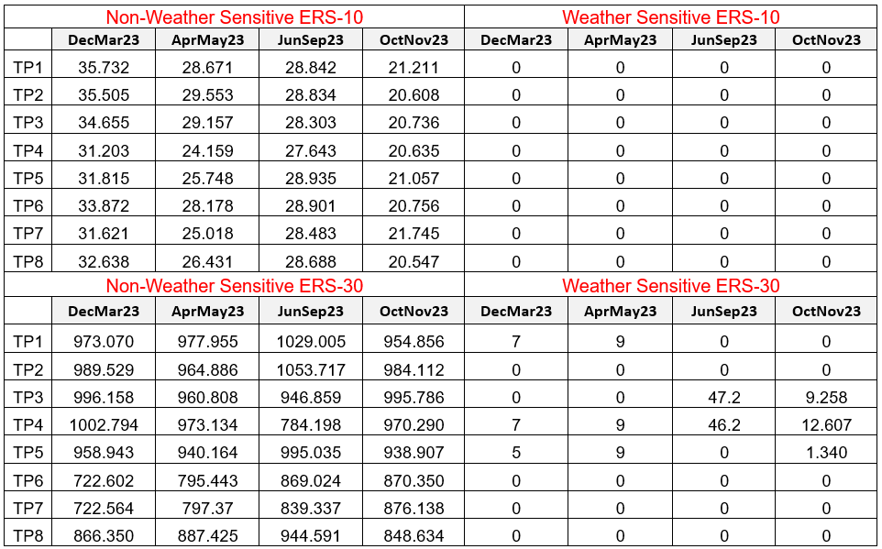



Table 11 below represents the MW-per-hour cost of ERS for each ERS Time Period dating back to the February through May 2021 SCT.

*Table 11: Unit cost per ERS Time Period per SCT*

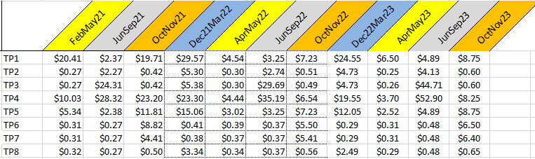

Starting with the February through May 2013 SCT, ERCOT implemented changes that allowed certain types of small generators to provide ERS if they are not a Generation Resource or a source of intermittent renewable generation. These ERS Generators can consist of an individual generator or an aggregation of such generators, and they participate in ERS by injecting energy into the ERCOT System. Graph 1 below shows the historical capacity procured from ERS Generators. Their historical participation peaked and leveled out at approximately 300 MW starting in 2016. This trend has remained constant over the program years since that time with only seasonal variations occurring.

*Graph 1: ERS Generator capacity procured, values are time and capacity weighted per each SCT*

Following each ERS SCT, ERCOT calculates the delivered amount of ERS capacity per QSE for each ERS Time Period based on test/event performance and availability results. The delivered amount of ERS capacity ultimately determines final settlement payments for QSEs. Graph 2 below shows the difference between the procured capacity and the delivered capacity for each SCT since the 2016 program year.

For graphical purposes, a single capacity value is shown that is time and capacity weighted across all ERS Time Periods for each SCT. The delivered amount of ERS capacity for the October through November 2023 SCT was not available at the time this report was produced. Due to tight reserve margins during the summers of 2018 and 2019, as well as a higher risk of ERS deployments during those periods, ERCOT did not perform ERS testing during the June through September SCTs for the 2018 and 2019 program years. As a result, delivered capacity was relatively equal to procured capacity for those SCTs, as shown in the graph.

*Graph 2: Procured versus delivered ERS capacity (values are time and capacity weighted per each SCT)*

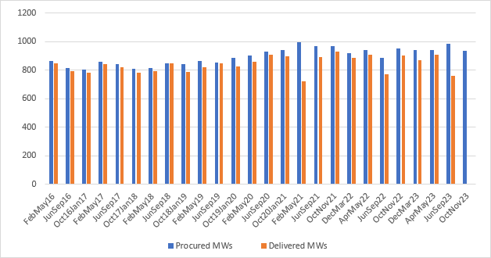

Graph 3 below provides an illustration of the procured capacity of ERS for each ERS SCT starting with the February through May 2016 SCT. These values represent the time and capacity weighted procured capacity and cost for each of all ERS Time Periods for each SCT. There was some expectation that capacity offered and procured for this service would show a noticeable increase since the annual spend limit was increased from $50 million to $75 million at the start of the 2023 program year but that has not yet been observed. One possible reason for that could be the expansion of the TDSP Load Management programs that now offer winter programs which compete for some of the same loads that have historically offered into ERS.

*Graph 3: Procured ERS Capacity versus Unit Cost (values are time and capacity weighted per each Standard Contract Term)*

As noted earlier, the rules for deploying ERS changed starting with the 2022 program year. During the 2023 program year, ERS was deployed twice, once on August 17, and again on September 6 when ERCOT’s PRC dropped below 3,000 MWs. Under the new procedures defined in NPRR 1106, both ERS-10 and ERS-30 Resources are deployed under a common Dispatch Instruction from ERCOT. The August 17 deployment instruction was issued at 19:17:27 during ERS Time Period 5. The recall for this event occurred at 20:08:55. Due to the extremely short duration of this deployment, there was not a full 15-minute Settlement Interval for the ERS-30 Resources to be measured by as required by Protocol § 8.1.3.1.4(2)(b) and therefore only the ERS-10 Resources were measured for performance for this event. Graph 4 below illustrates the ERS-10 Resources’ response of approximately 35 MW, or 120% of their 28.935 MW obligation, during the event’s sustained response period.

*Graph 4: August 17, 2023, ERS Deployment Event*

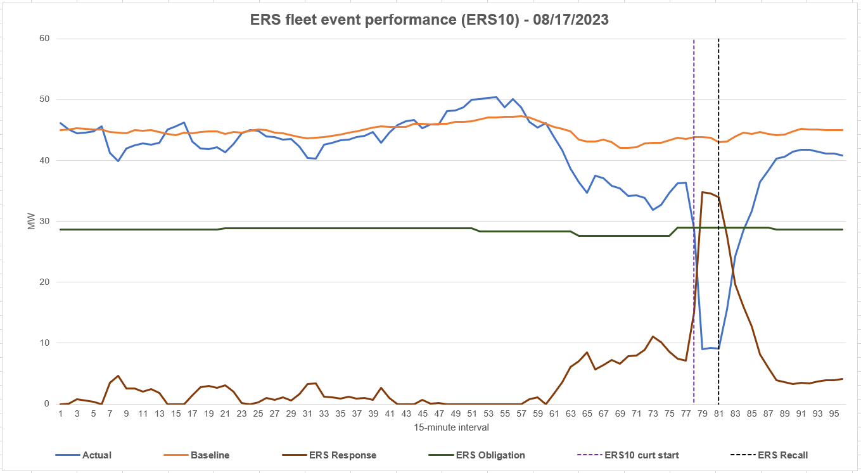

The September 6 deployment event was initiated by ERCOT Dispatch Instruction at 19:14:21 and recalled at 20:44:21. The combined ERS-10 and ERS-30 obligation for this deployment event was 995.035 MW. Graph 5 below shows that the fleet-wide response was slow to meet its required minimum deployment level during the sustained response period. Under the Protocols, a minimum response of 95% of the obligation is required to meet the performance metric. The response during the first full interval of the sustained response period for this event was 90.8% of its obligation. By the end of the sustained response period, the fleet-wide response improved to 99.4%. For this deployment event the overall event performance factor was 93.7%.

*Graph 5: September 6, 2023, ERS Deployment Event*

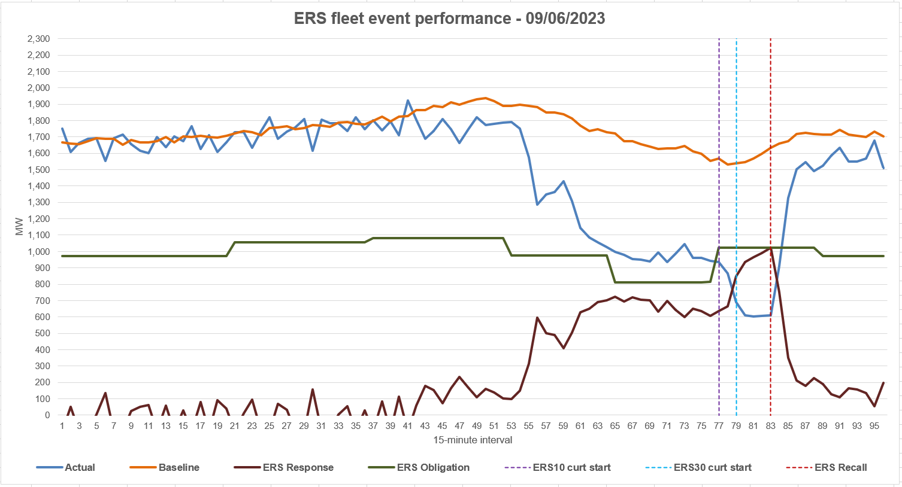

**TDSP Load Management Programs**

The TDSP Load Management Program refers to any program created pursuant to Public Utility Regulatory Act, Texas Utilities Code §§ 36.204 and 39.905 and 16 TAC § 25.181. In these programs, end-use customers agree to receive payment from a TDSP in exchange for reducing peak demand for a specified duration upon request by the TDSP. These programs have historically only been offered during the summer months of June, July, August, and September in the service territories for AEP Texas, CenterPoint, Oncor, and Texas New Mexico Power (TNMP). In late 2021, the offerings changed as each of these four TDSPs additionally offered interim programs during the 2021-2022 winter period. Those interim programs were extended for the 2022-2023 winter period. Table 12 provides a summary of each of those programs.

*Table 12: TDSP Winter Interim Load Management Program Summary*

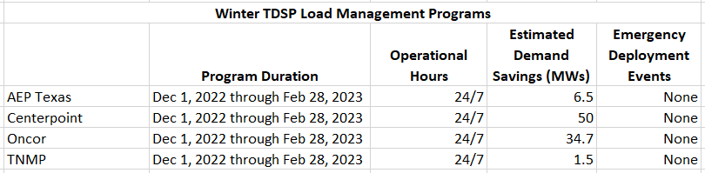

In regard to the TDSP Load Management programs offered during the summer months, there are some variations in these programs. AEP Texas, CenterPoint and TNMP’s program parameters for the summer remained generally unchanged from previous years. They are only available during weekdays from June 1 through September 30, between the hours of 1:00 p.m. and 7:00 p.m. Oncor however modified their program to be available for deployment 24/7. Also, historically there were some variations in the deployment ramp times among the four programs but starting in 2022 they all aligned with a 30-minute ramp. Table 13 provides a description of the TDSP Load Management programs for the June 1 through September 30, 2023, program year. Because the verified demand savings were not known at the time of this report, the estimated demand savings are provided. It should also be noted that AEP Texas offers different options for their program, with some options only available during August and September, which is the reason that two numbers are presented for their estimated demand savings.

*Table 13: TDSP Summer Load Management Program Summary*



Through an agreement between the TDSPs and ERCOT, these Loads may be deployed by an ERCOT instruction during an EEA Level 2. However, this agreement does not prohibit the TDSPs from deploying these programs for either testing purposes or for their own use. There were no ERCOT-initiated emergency deployment events during the 2023 summer period.

**4CP Load Reduction and Price-Responsive Demand Response**[3]

Beginning in 2013 and continuing annually under the guidance of the Retail Market Subcommittee (RMS) and the Demand Side Working Group (DSWG), ERCOT has conducted retail Demand response and dynamic pricing surveys to determine the magnitude of participation in Demand response products offered by Retail Electric Providers (REPs) operating in the ERCOT Region. Starting in 2018, ERCOT also began collecting Demand response data from Non-Opt-In Entities (NOIEs).

*REP Survey Process*

Starting in 2019 and continuing through 2023, ERCOT targeted the survey to the largest REPs (considering the aggregate Load of sets of affiliated REPs), which collectively accounted for 98% of the ERCOT total Summer 2022 average daily Load. Initially, each REP was sent an email requiring a reply indicating whether the REP offered Demand/price response programs to its customers. REPs responding in the affirmative were then required to submit additional data to ERCOT in conjunction with those programs. Note that year-to-year variations in REPs targeted for the survey can have an influence on the analysis results when compared across years.

The REP survey collected specific ESIID participation data for the following Demand response categories:

* 4CP Advisory/Control (4CP)
* Indexed Real-Time (IRT)
* Indexed Day-Ahead (IDA)
* Critical Peak Pricing (CPP)
* Peak Rebates (PR)
* Time of Use (TOU) pricing
* Free Days and/or Hours (FDH)
* Other Direct Load Control (OLC)
* Other Voluntary DR Product (OTH)
* Block & Index (BI) - discontinued in 2020
* Real-Time Pricing (RTP) - discontinued in 2020

In the survey, targeted REPs were asked to submit files listing the ESIIDs of customers participating in one or more of the listed products as of the annual snapshot date of September 1, 2023.[4] REPs were also required to submit deployment event information for applicable programs, including dates and times of deployments as well as the number of residential and non-residential customers deployed for each event.

*NOIE Survey Process*

Since customer-level data for customers in NOIE areas is not available to ERCOT, ERCOT has made use of the calculated NOIE native load data in the ERCOT settlement system to perform an analysis of NOIE response to 4CP/NearCP and high price events.

NOIEs with 2022 summer peak load of 100 MW or more were sent an email requiring a reply indicating whether the NOIE offered Demand/price response programs to its customers. NOIEs responding in the affirmative were then required to submit additional data to ERCOT in conjunction with those programs. For NOIE TDSPs with matching DUNS numbers, loads were aggregated to determine whether the 100 MW threshold was met.

The additional data required from NOIEs consisted of counts of residential and non-residential customers participating in the various program categories as of the September 1, 2022, snapshot date. To the extent the NOIE was operating deployment-type programs, NOIEs also were asked to provide the dates and times of those deployments as well as the number of residential and non-residential customers for each event.

The NOIE survey included the categories used for the REP survey, as well as the following additional categories:

* 4CP Incentive
* Conservation Voltage Reduction (CVR)

*Data Analysis Overview*[5]

ERCOT conducted a detailed analysis of the ESIIDs submitted by the REPs using interval meter data stored in the ERCOT settlement database. The analysis objective was to develop estimates of the amount of Load reduction produced by the various programs for days with high prices and other deployments applicable to the program category.

The analysis typically involves looking at three years of historical data, and exceptional events during the analysis window are taken into consideration. For the 2023 analysis, two exceptional events were considered: Hurricane Nicholas and Winter Storm Uri, both in 2021. The analysis methodology was adapted to account for the impact these events had on customer Load patterns, based on the nature of the specific events. An algorithm ERCOT developed in 2017 for Hurricane Harvey was leveraged to identify specific ESIIDs and dates that appeared to be impacted by Hurricane Nicholas, and the data for those ESIDs and dates was excluded from use in the individual ESIID and NOIE baseline development. The approach adopted for Winter Storm Uri was to exclude data for February 2021.

Finally, with the addition to the grid of large cryptomining Loads, ERCOT analysis has found price response occurring at much lower levels than had previously been observed. Known crypto ESIIDs were flagged, and the analysis methodology was modified to apply the Meter-Before-Meter-After baseline and thus avoid the likely bias that would have otherwise occurred in determining the baseline. ERCOT will continue to work on a method to identify additional ESIIDs that respond at low prices, and, if required, re-run the analysis and update this and prior year’s reports.

*4CP Analysis*

The four coincident peaks, or “4CP”, in ERCOT are the four 15-minute Settlement Intervals corresponding with the highest ERCOT Load in each of the four summer months (June, July, August, and September). For NOIEs and certain retail choice customers, the average of the 4CP Loads establishes the share of cost responsibility for transmission charges. 4CP billing can incentivize customers to reduce Load during anticipated 4CP intervals.

ERCOT separately analyzed the response behavior for both NOIEs and ESIIDs in competitive choice areas subject to 4CP charges. 4CP response for NOIEs was based on estimated reductions in total NOIE Load, as determined from boundary metering after netting out NOIE-area generation. Response in competitive areas was estimated based on the TDSP metering of the customer’s actual Load. In both cases, reductions were estimated for actual 4CP days as well as other “Near-CP” days. These Near-CP days were determined by identifying summer days on which the ERCOT total Load was high and for which significant Load reductions were observed among transmission voltage customers identified as 4CP responders during the summer prior to the survey year.

ERCOT’s practice with 4CP analysis is to base the Load reduction estimates on ESIIDs that have demonstrated a likelihood to respond to 4CP and Near-CP events. The likelihood is determined from the ESIID’s response to such events over the most recent three-year period, including summer 2023.

In the areas of ERCOT with retail competition, customers subject to 4CP billing largely make their own decisions, independent of their REP, on a day-by-day basis as to whether to reduce Load to avoid 4CP-based charges. Given this, the REP survey is not used directly to identify ESIIDs that take action to avoid those charges. However, the REP survey data is an important input into the 4CP analysis in that it identifies ESIIDs that are on indexed pricing products and/or that participate in REP deployment type products. This information allows ERCOT to identify days to exclude from its baseline evaluation and determination.

The same considerations apply to the NOIE survey, with the exception that it is done at the NOIE total Load level. For NOIE Load analysis, high price days and deployment days (including those for 4CP and other programs) are excluded from the baseline development.

*REP and NOIE Participation Results*

Using the REP and NOIE survey data, ERCOT has compiled the number of ESIIDs/accounts participating in the various Demand/Price Response categories, as shown in Tables 14 and 15 below.

Table 14: REP Reported Price-Responsive Demand Response (DR) and 4CP Load Reduction Participation (based on 2014 - 2023 data)



Table 15: NOIE Reported Price-Responsive Demand Response (DR) and 4CP Load Reduction Participation (based on 2014 - 2023 data)





Issues to note when considering the participation numbers:

1. Pricing category definitions and identifications were changed starting with the 2020 survey.
   1. The B&I category, which was not surveyed after 2019, was applicable only to Non-Residential ESIIDs/Accounts
   2. The RTP category, which was not surveyed after 2019, applied to all ESIIDs/accounts, but was limited to indexing based on Real-Time prices.
   3. Two new categories, IRT and IDA, were surveyed starting in 2020 and apply to all ESIIDs/Accounts and capture both types of indexing.
   4. The survey also included an Indexed Other category to accommodate any other type of indexing; based on the REP’s description of their Indexed Other program, for analysis purposes, the ESIIDs reported as participating on this program were treated as participating in an IRT program.
2. The OTH category is included in the survey to capture participation in a program type that doesn’t fit in any of the pre-defined survey categories.
   1. Some participation was reported by REPs in this category for 2023.
   2. Based on discussions with the involved REPs, some of the ESIIDs were treated as participating in an Indexed pricing program, and others were treated as participating on a PR program.
   3. A significant portion of the NOIE participation in 2019 reflected NOIE adoption of CVR programs. This contributed to the addition of CVR as a separate survey category specific to NOIEs starting with the 2020 survey process.
   4. For the 2020 - 2023 surveys, a significant fraction of the NOIE participation in the Other Category was found to be in Behavioral Demand Response type programs.
3. The 4CP Incentive program category is specific to the NOIE survey and was included for the first time in 2019. This category provides for a way to distinguish the less direct 4CP incentive program from the 4CP Advise/Control program. It should be noted that TDSPs in the competitive areas of ERCOT have modified their Tariffs such that all ESIIDs with peak demands over 700 kW have an incentive to avoid 4CP charges. Several REPs are offering 4CP advisory services, and the ESIIDs participating are reported to ERCOT as part of the Annual Demand Response Survey.

*Demand/Price Load Reduction Results*

The two tables below show findings associated with the 26 summer days in 2023 for which the Load reduction amounts at the system-level exceeded 3,500 MW, after accounting for any overlap across categories. Table 8 shows the amount of Load reduction in MW on the various days, and Table 9 shows the number of ESIIDs/NOIEs identified as responding on those days. All 26 days had 4CP-related Load reductions, and 18 of those days were also high price days.

Load reductions for an additional set of 18 4CP/Near CP days and high-price days were identified and analyzed, but did not meet the 3,500 MW threshold and, for brevity, were omitted from this report.

NOIE Load reduction estimates were only developed for high price days or days identified as 4CP/Near-CP days; however, several NOIEs did deploy their Load reduction programs on other days.

For this report, Load reduction estimates were developed at the premise level for ESIIDs with Non-controllable Load Resources that were deployed for RRS, ECRS, and Non-Spin. One or more of these Ancillary Services were deployed from Non-controllable Load Resources on three days in the summer of 2023: June 20, July 13, and September 6; the reported ESIID premise-level load reduction amounts can be attributed to meeting Ancillary Service responsibilities as well as curtailment of other non-Load Resource load associated with the ESIIDs.

Load reduction estimates were also developed at the premise level for ESIIDs deployed by ERCOT’s ERS program. ERS was deployed on August 17 and September 6. The reported load reductions were only developed for ESIIDs participating in the competitive region of ERCOT; the reported load reduction amounts can be attributed to meeting ERS obligations and potentially curtailment of other non-ERS load associated with the ESIIDs.

Empty cells in the tables below are attributable to the following:

1. If prices were not high on specific 4CP and NearCP days, reduction estimates were developed for ESIIDs on Indexed Pricing only if the ESIIDs were identified as 4CP responders. For such days, the Indexed Pricing entries are left blank.
2. Deployment-based programs were only evaluated on days for which the REP reported having deployed the program. If the REP program was not deployed on a specific high-price or 4CP/NearCP day, the table entry is left blank for that day.

Some other items of note when considering the reported values:

1. MW reductions reported are all for Hour Ending 17 to ensure consistency. In some cases, the Load reductions shown are not in alignment with the high prices on that day or with the program deployment times. As a result, reductions reported here may not match those reported elsewhere for other Operating Hours.
2. Export from Settlement-Only Generators (SOGs) is not included in this table. If a Load reduction was effectuated by operating behind-the-meter generators, the reduction is still treated as Load reduction in this report.

Table 16 below shows the Load reduction for each of the program categories on the specific day listed. The amounts shown in the “Total System DR” column reflect summation of Load reduction across the various program categories and eliminates double counting when ESIIDs participate in more than one program or when NOIEs are identified as responding to both 4CP and high prices. The “Overlap” column is the difference between the amount in the “Category Total” column and the “Total System DR” column. Thus, the Overlap amount is the measure of double counting in the Category Total column.

Table 16: High Load Reduction Days 2023, at Total System-Level and at Category-level – MW Reductions



Table 17 below covers the same dates as shown in Table 8 and reports the number of ESIIDs and NOIEs identified as responding on those particular days. For this table, the measure of double counting is also reflected in the “Overlap” columns, and the “Total System DR” column reflects the total number of unique ESIIDs and NOIEs responding on each day.

*Table 17: High Load Reduction Days 2023, at Total System-Level and at Category-level – ESIID/NOIE Counts*



The graphs below show the load reductions occurring at the system level. The baseline, actual, and reduction loads graphed are aggregated over the ESIIDs and NOIEs identified as responding on the specific days. August 9, 2023 is the day on which the largest load reduction amount occurred. August 10, 2023 is the day of the ERCOT highest 15-minute peak.

August 17, 2023 had $1,000+/MWh Load Zone prices for intervals 56 - 83 and $5,000+/MWh Load Zone prices for intervals 77 - 82. ERS was also deployed starting in interval 78.

September 6, 2023 had $1,000+/MWh Load Zone prices for intervals 60 - 69 and 71 - 82 and $5,000+/MWh Load Zone prices for intervals 64 - 66 and 77 - 81. ERS and Non-controllable Load Resources were also deployed starting in interval 78.

Graph 6: System-level Load Reductions for Responding ESIIDs based on Summer 2023 data

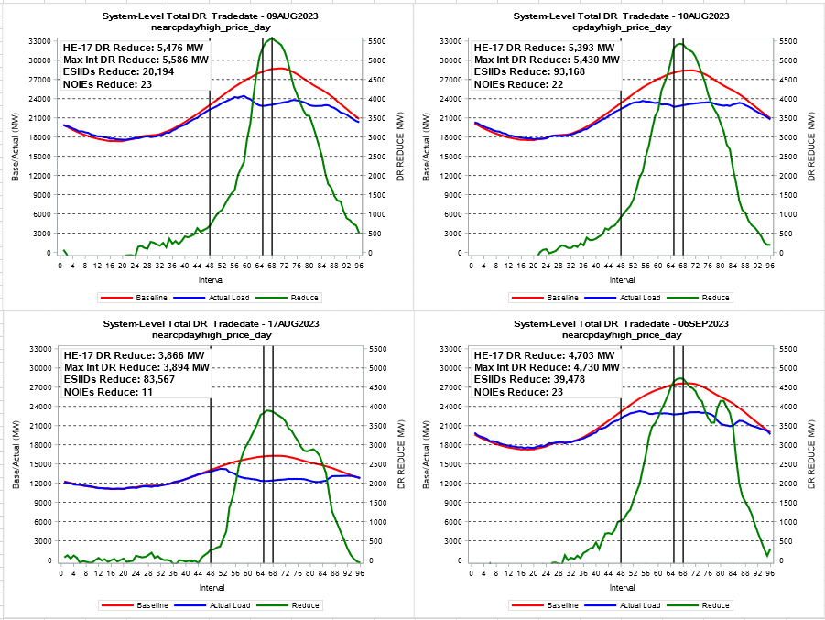

1. ERCOT Protocol § 3.10.7.2.2 requires that ERCOT post a Demand response report, on an annual basis, no later than December 31 each calendar year. Because of the December 31 posting deadline, some sections of this report only include data for January through November of 2023. For those sections, data for December 2023 will be included in the annual report posted by ERCOT in December 2024.
2. Available at: https://www.ercot.com/services/programs/load/.
3. ERCOT intends to produce an analysis for Settlement-Only Generation price response, but this analysis was not complete at the time of the publishing of this report. A supplemental report will be published when this analysis is complete.
4. From 2014 to 2019, the annual snapshot date for the survey was September 30 of the survey year.
5. Because time-of-use and variations of free-days/hours products are designed to incent long-term consumption behavior shifts, rather than event-based Demand response, ERCOT does not include analysis of those products in this report.